**LAB REPORT 5**

**Name:- Ayush Kumar Gupta**

**ROLL NO:- 2023114001**

**1.OBJECTIVE –** To Form RS OR Latch and check input results.

**ELCTRONIC COMPONENTS REQUIRED -**

1. Digital test kit.
2. NOR Gate.

**PROCEDURE:**

1. Test the ICs, LED Lights and Switches.
2. Connect ICs with GND, Power.
3. ­­­­­­­Connect the circuit as given in reference circuit. A diagram of a block diagram

   Description automatically generated
4. Check the output with following order:

S R = 01, 00, 10, 00, 01, 10, 01, 00, 11, 00, 10, 11, 00, 01, 11, 00.

Observe the output and make the Table.

|  |  |  |  |
| --- | --- | --- | --- |
| S | R | Output | Output’ |
| 0 | 1 | 0 | 1 |
| 0 | 0 | 0 | 1 |
| 1 | 0 | 1 | 0 |
| 0 | 0 | 1 | 0 |
| 0 | 1 | 0 | 1 |
| 1 | 0 | 1 | 0 |
| 0 | 1 | 0 | 1 |
| 0 | 0 | 0 | 1 |
| 1 | 1 | 0 | 0 |
| 0 | 0 | 0 | 1 |
| 0 | 1 | 0 | 1 |
| 1 | 1 | 0 | 0 |
| 0 | 0 | 1 | 0 |

Conclusion:

On SR value of 01, Latch gets reset to 01.

On SR value of 00, Latch retains the previous value.

On SR value of 10, Latch gets set to 10.

On SR value of 11, Latch gets to forbidden state of 00, which changes differently on applying 00.

**LINK FOR TINKERCAD SIMULATION :**

[**https://www.tinkercad.com/things/7r0Zb17dzcr-sr-latch/editel?sharecode=izayfHMT5YSZk3DXaK5ZqqhrrDPLI9wkxXfVaCVNNW0**](https://www.tinkercad.com/things/7r0Zb17dzcr-sr-latch/editel?sharecode=izayfHMT5YSZk3DXaK5ZqqhrrDPLI9wkxXfVaCVNNW0)

**TINKERCARD :**

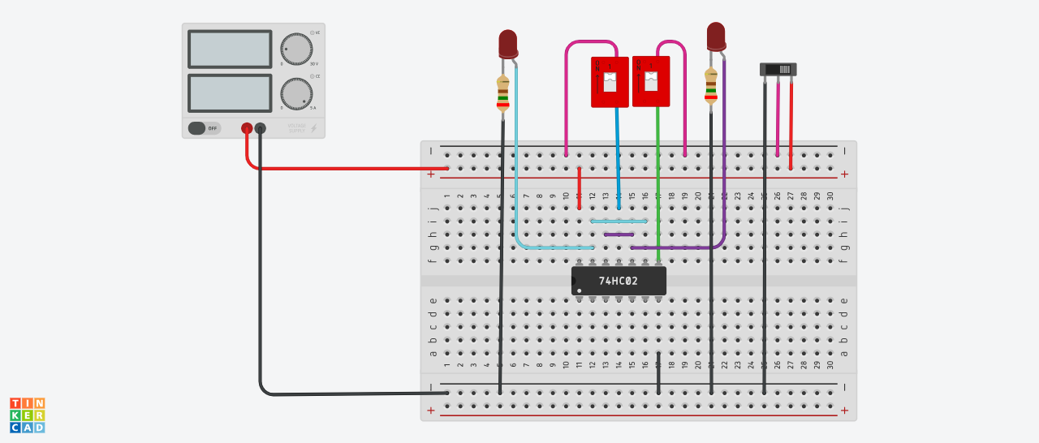

LAB: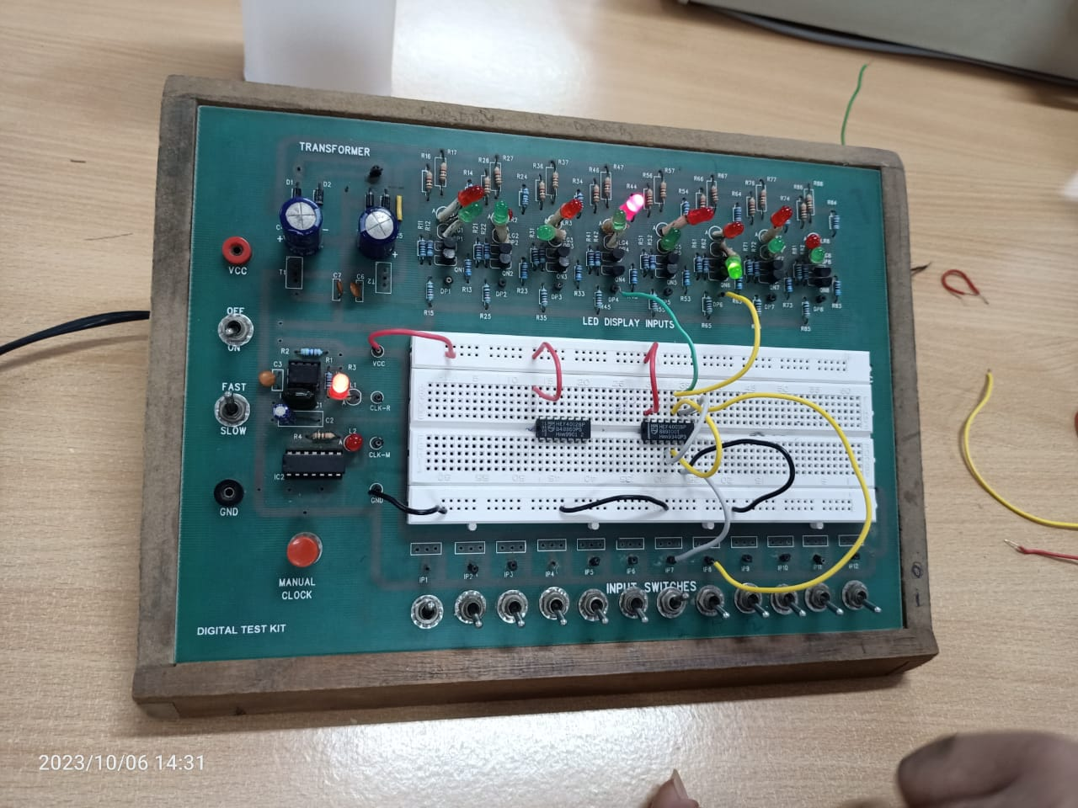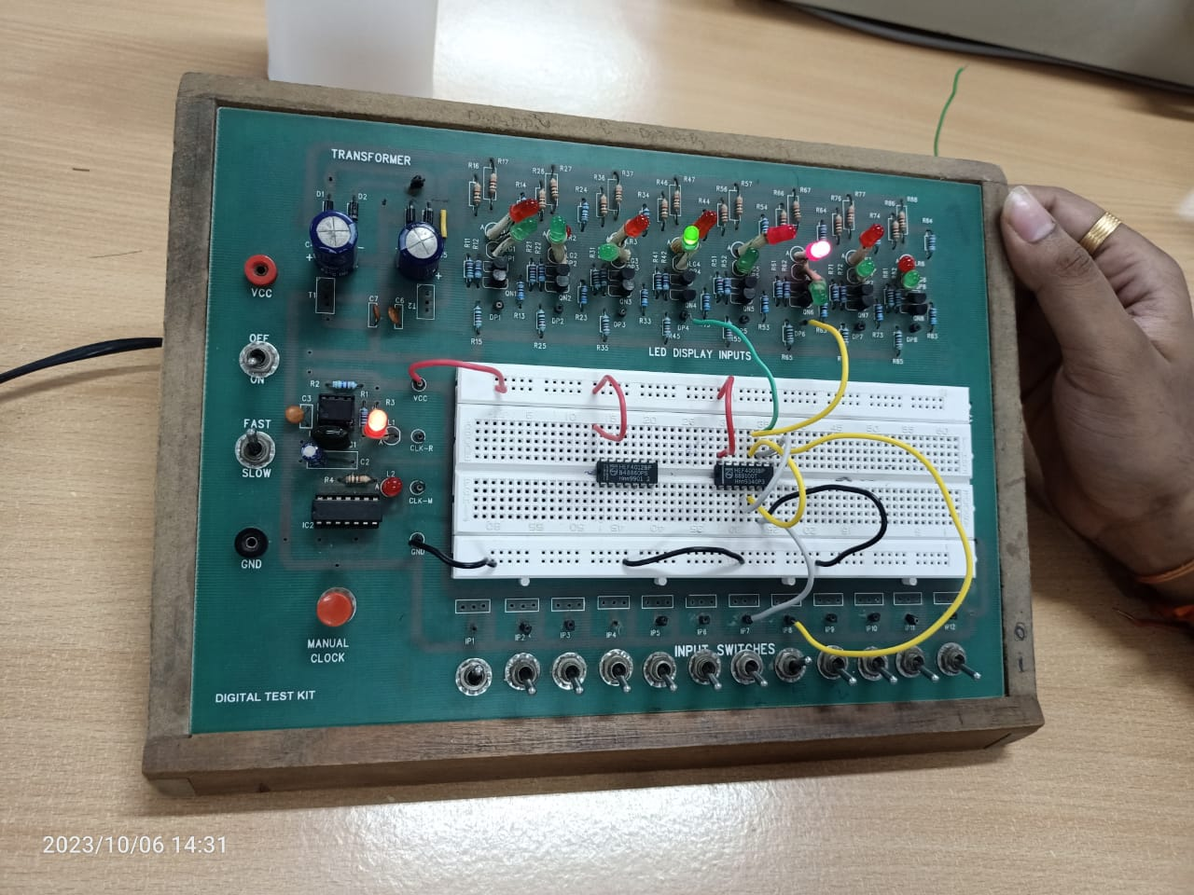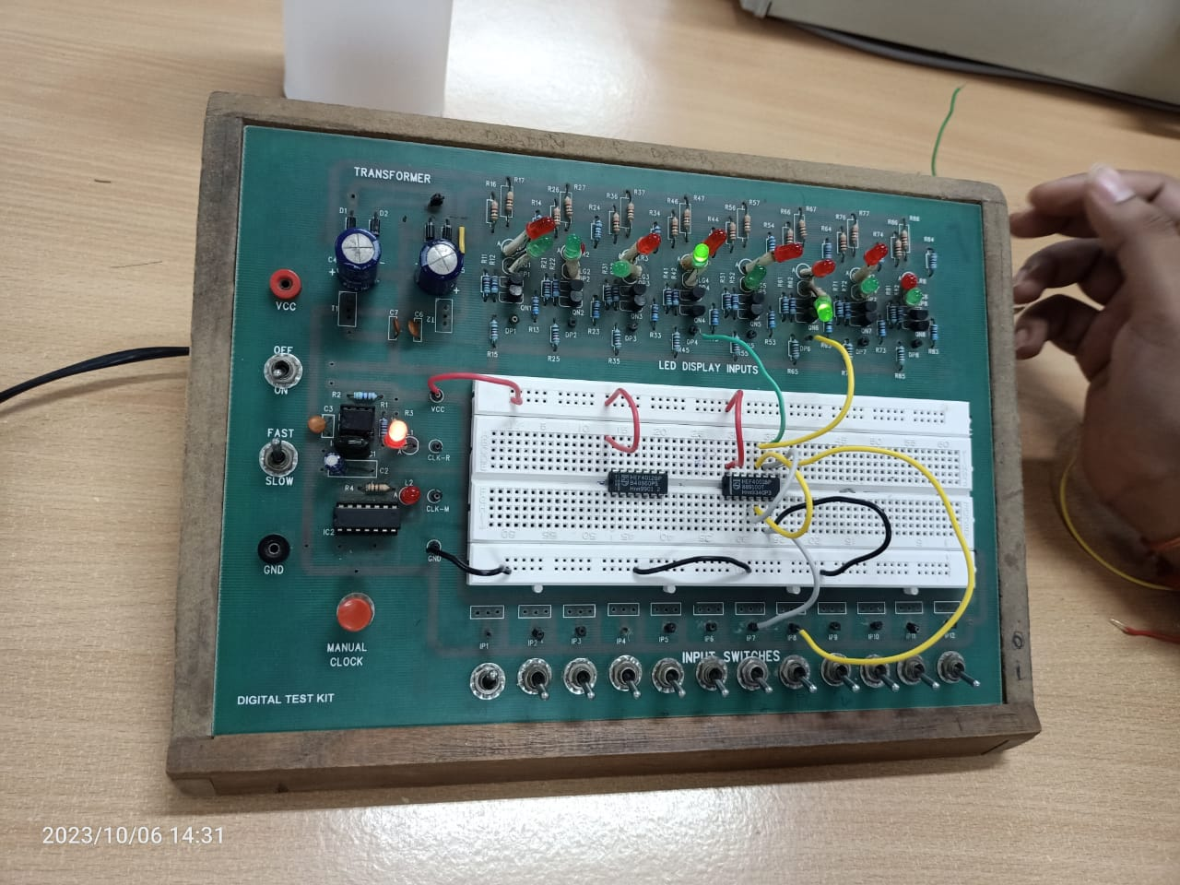

**2.OBJECTIVE –** To Form JK Flip Flop and Observe its Output.

**ELCTRONIC COMPONENTS REQUIRED –**

1. Digital test kit.
2. 2-Input And Gate IC.
3. 3-Input And gate IC.
4. Inverter IC.
5. LEDs.

**PROCEDURE:**

* Test the ICs, LED Lights and Switches.
* Connect ICs with GND, Power.
* ­­­­­­­Connect the circuit as given in reference circuit.

Observe the output and make the Table.

|  |  |  |  |
| --- | --- | --- | --- |
| J | K | Enable | Q(t+1) |
| 0 | 0 | 0 | Qt |
| 0 | 0 | 1 | Qt |
| 0 | 1 | 0 | Qt |
| 0 | 1 | 1 | 0 |
| 1 | 0 | 0 | Qt |
| 1 | 0 | 1 | 1 |
| 1 | 1 | 0 | Qt |
| 1 | 1 | 1 | Toggle |

Conclusion:

On JK value of 01, It gets reset to 01.

On JK value of 00, It retains the previous value.

On JK value of 10, It gets set to 10.

On JK value of 11, It gets to toggle state.

**LINK FOR TINKERCAD SIMULATION :**

<https://www.tinkercad.com/things/i5eHVFlc7cu-fantastic-wluff-snaget/editel?sharecode=lXAk7PaWkzR1lc40NGXpDJyytDkwnx5tTiaxJykD9FI>

**TINKERCARD :**

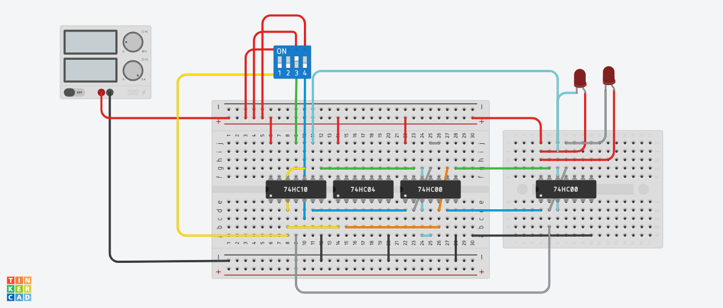

**3.OBJECTIVE –** To Form 4-Bity UP Down Counter.

**ELCTRONIC COMPONENTS REQUIRED –**

1. Digital test kit.
2. Arduino.
3. LEDs.

**PROCEDURE:**

* Test the LED Lights and Arduino.
* Connect Arduino with GND, Power.
* ­­­­­­­Connect the Input to Arduino and Output it to LEDs.
* Write Code to print them.

**LINK FOR TINKERCAD SIMULATION :**

<https://www.tinkercad.com/things/0u2KkKv7p1h-printer/editel?sharecode=DUlNu-SgCi8KDesXdnVg3dwje29ufYw0DCeeE1x53o0>

**TINKERCARD :**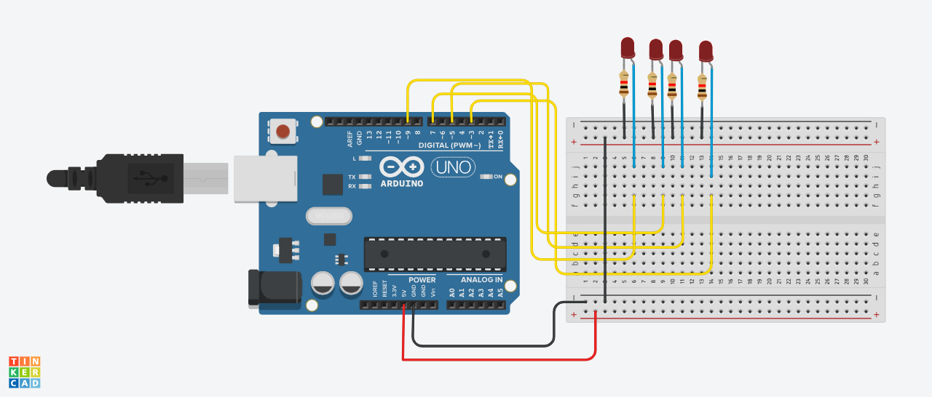

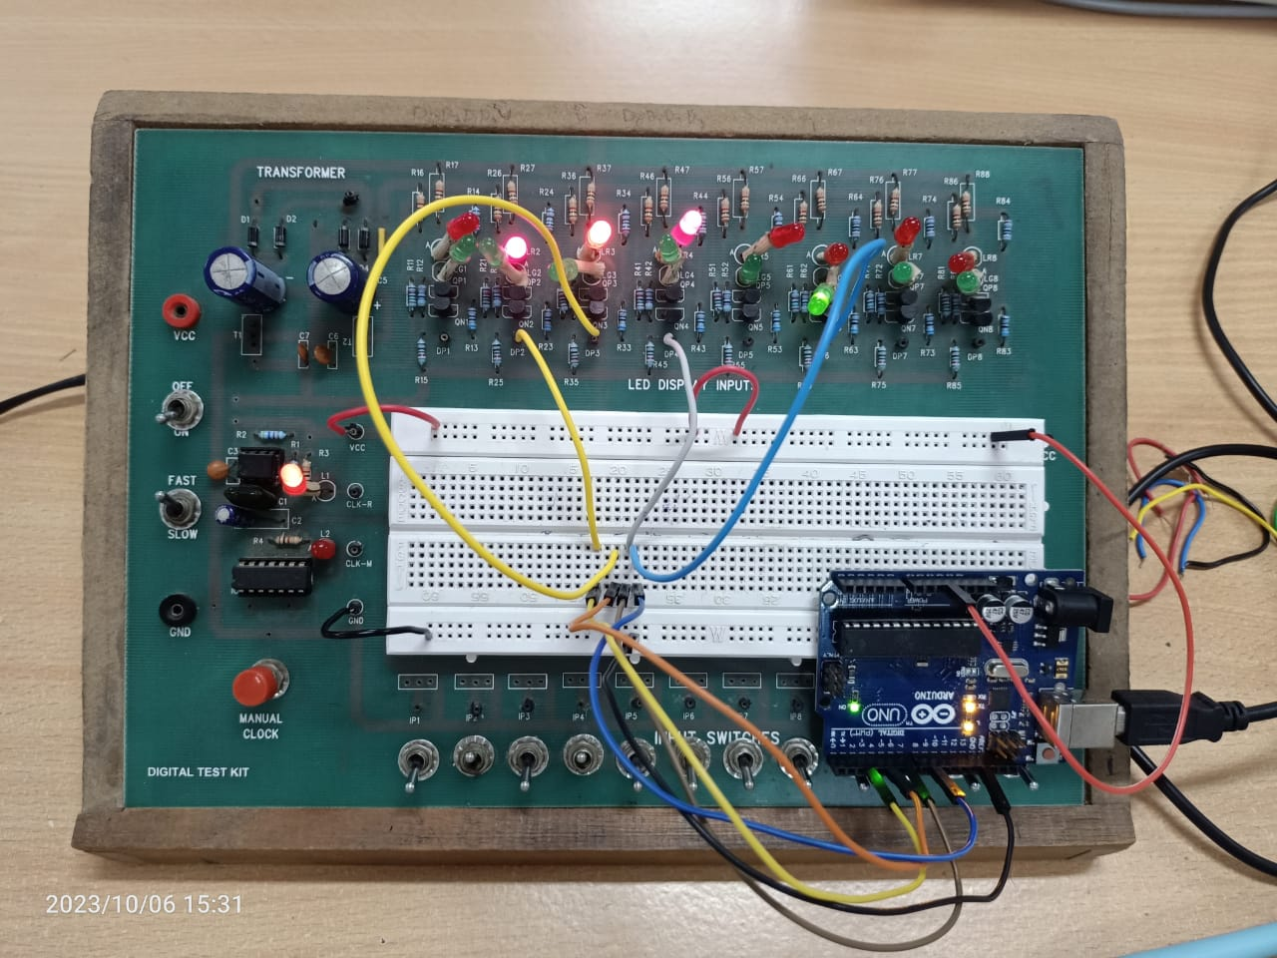

CODE:

#ifndef Event_h

#define Event_h

#include <inttypes.h>

#define EVENT_NONE 0

#define EVENT_EVERY 1

#define EVENT_OSCILLATE 2

class Event {

public:

Event(void);

void update(void);

void update(unsigned long now);

int8_t eventType;

unsigned long period;

int repeatCount;

uint8_t pin;

uint8_t pinState;

void (*callback)(void);

unsigned long lastEventTime;

int count;

};

#endif

#ifndef Timer_h

#define Timer_h

#include <inttypes.h>

#define MAX_NUMBER_OF_EVENTS (10)

#define TIMER_NOT_AN_EVENT (-2)

#define NO_TIMER_AVAILABLE (-1)

class Timer {

public:

Timer(void);

int8_t every(unsigned long period, void (*callback)(void));

int8_t every(unsigned long period, void (*callback)(void), int repeatCount);

int8_t after(unsigned long duration, void (*callback)(void));

int8_t oscillate(uint8_t pin, unsigned long period, uint8_t startingValue);

int8_t oscillate(uint8_t pin, unsigned long period, uint8_t startingValue, int repeatCount);

int8_t pulse(uint8_t pin, unsigned long period, uint8_t startingValue);

int8_t pulseImmediate(uint8_t pin, unsigned long period, uint8_t pulseValue);

void stop(int8_t id);

void update(void);

void update(unsigned long now);

protected:

Event _events[MAX_NUMBER_OF_EVENTS];

int8_t findFreeEventIndex(void);

};

#endif

Timer t;

int pin1 = 3;

int pin2 = 5;

int pin3 = 7;

int pin4 = 9;

int eventId1;

int eventId2;

int eventId3;

int eventId4;

void setup() {

Serial.begin(9600);

pinMode(pin1, OUTPUT);

pinMode(pin2, OUTPUT);

pinMode(pin3, OUTPUT);

pinMode(pin4, OUTPUT);

eventId1 = t.oscillate(pin1, 1000, LOW);

if (eventId1 < 0) {

Serial.println("Could not initialize timer"); }

eventId2 = t.oscillate(pin2, 2000, LOW);

if (eventId2 < 0) {

Serial.println("Could not initialize timer"); }

eventId3 = t.oscillate(pin3, 4000, LOW);

if (eventId3 < 0) {

Serial.println("Could not initialize timer"); }

eventId4 = t.oscillate(pin4, 8000, LOW);

if (eventId4 < 0) {

Serial.println("Could not initialize timer"); }

t.every(16000, takeReading);

}

void loop() {

t.update();

}

void takeReading(){

eventId1 = t.oscillate(pin1, 1000, HIGH);

if (eventId1 < 0) {

Serial.println("Could not initialize timer"); }

eventId2 = t.oscillate(pin2, 2000, HIGH);

if (eventId2 < 0) {

Serial.println("Could not initialize timer"); }

eventId3 = t.oscillate(pin3, 4000, HIGH);

if (eventId3 < 0) {

Serial.println("Could not initialize timer"); }

eventId4 = t.oscillate(pin4, 8000, HIGH);

if (eventId4 < 0) {

Serial.println("Could not initialize timer"); }

}

void stopAllTimers() {

}

Event::Event(void)

{

eventType = EVENT_NONE;

}

void Event::update(void)

{

unsigned long now = millis();

update(now);

}

void Event::update(unsigned long now)

{

if (now - lastEventTime >= period)

{

switch (eventType)

{

case EVENT_EVERY:

(*callback)();

break;

case EVENT_OSCILLATE:

pinState = ! pinState;

digitalWrite(pin, pinState);

break;

}

lastEventTime = now;

count++;

}

if (repeatCount > -1 && count >= repeatCount)

{

eventType = EVENT_NONE;

}

}

Timer::Timer(void)

{

}

int8_t Timer::every(unsigned long period, void (*callback)(), int repeatCount)

{

int8_t i = findFreeEventIndex();

if (i == -1) return -1;

_events[i].eventType = EVENT_EVERY;

_events[i].period = period;

_events[i].repeatCount = repeatCount;

_events[i].callback = callback;

_events[i].lastEventTime = millis();

_events[i].count = 0;

return i; }

int8_t Timer::every(unsigned long period, void (*callback)())

{

return every(period, callback, -1); // - means forever

}

int8_t Timer::after(unsigned long period, void (*callback)())

{

return every(period, callback, 1);

}

int8_t Timer::oscillate(uint8_t pin, unsigned long period, uint8_t startingValue, int repeatCount)

{

int8_t i = findFreeEventIndex();

if (i == NO_TIMER_AVAILABLE) return NO_TIMER_AVAILABLE;

_events[i].eventType = EVENT_OSCILLATE;

_events[i].pin = pin;

_events[i].period = period;

_events[i].pinState = startingValue;

digitalWrite(pin, startingValue);

_events[i].repeatCount = repeatCount * 2; // full cycles not transitions

_events[i].lastEventTime = millis();

_events[i].count = 0;

return i;

}

int8_t Timer::oscillate(uint8_t pin, unsigned long period, uint8_t startingValue)

{

return oscillate(pin, period, startingValue, -

1); // forever

}

int8_t Timer::pulse(uint8_t pin, unsigned long period, uint8_t startingValue)

{

return oscillate(pin, period, startingValue, 1); // once

}

int8_t Timer::pulseImmediate(uint8_t pin, unsigned long period, uint8_t pulseValue)

{

int8_t id(oscillate(pin, period, pulseValue, 1)) ;

// now fix the repeat count

if (id >= 0 && id < MAX_NUMBER_OF_EVENTS) {

_events[id].repeatCount = 1;

}

return id; }

void Timer::stop(int8_t id)

{

if (id >= 0 && id < MAX_NUMBER_OF_EVENTS) {

_events[id].eventType = EVENT_NONE;

} }

void Timer::update(void)

{

unsigned long now = millis();

update(now);

}

void Timer::update(unsigned long now)

{

for (int8_t i = 0; i < MAX_NUMBER_OF_EVENTS; i++

)

{

if (_events[i].eventType != EVENT_NONE)

{

_events[i].update(now);

}

} }

int8_t Timer::findFreeEventIndex(void) {

for (int8_t i = 0; i < MAX_NUMBER_OF_EVENTS; i++

)

{

if (_events[i].eventType == EVENT_NONE)

{

return i; }

}

return NO_TIMER_AVAILABLE;

}